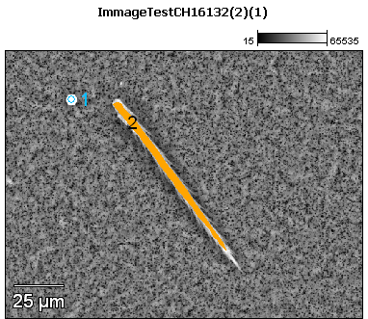

Image Name: ImmageTestCH16132(2)(1)

Image Resolution: 512 by 384

Image Pixel Size: 0.35 µm

Acc. Voltage: 17.0 kV

Magnification: 700

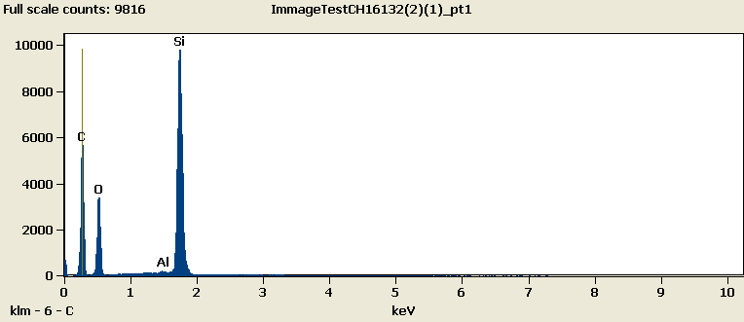

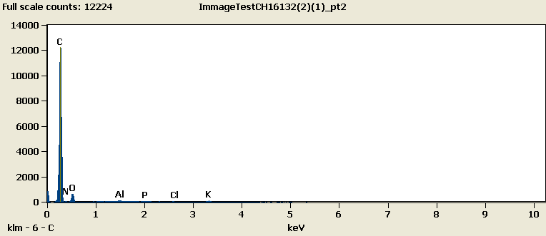

Weight %

|  |  |  |  |  |  |  |  |  |
| --- | --- | --- | --- | --- | --- | --- | --- | --- |
|  | ***C-K*** | ***N-K*** | ***O-K*** | ***Al-K*** | ***Si-K*** | ***P-K*** | ***Cl-K*** | ***K-K*** |
| ***ImmageTestCH16132(2)(1)_pt1*** | 57.78 |  | 25.85 | 0.04 | 16.32 |  |  |  |
| ***ImmageTestCH16132(2)(1)_pt2*** | 55.47 | 35.75 | 7.70 | 0.23 |  | 0.21 | 0.09 | 0.55 |

Weight % Error (+/- 1 Sigma)

|  |  |  |  |  |  |  |  |  |
| --- | --- | --- | --- | --- | --- | --- | --- | --- |
|  | ***C-K*** | ***N-K*** | ***O-K*** | ***Al-K*** | ***Si-K*** | ***P-K*** | ***Cl-K*** | ***K-K*** |
| ***ImmageTestCH16132(2)(1)_pt1*** | ±0.35 |  | ±0.25 | ±0.02 | ±0.07 |  |  |  |
| ***ImmageTestCH16132(2)(1)_pt2*** | ±0.81 | ±2.86 | ±0.54 | ±0.02 |  | ±0.02 | ±0.02 | ±0.03 |

# Cations

|  |  |  |  |  |  |  |  |  |
| --- | --- | --- | --- | --- | --- | --- | --- | --- |
|  | ***C-K*** | ***N-K*** | ***O-K*** | ***Al-K*** | ***Si-K*** | ***P-K*** | ***Cl-K*** | ***K-K*** |
| ***ImmageTestCH16132(2)(1)_pt1*** | 0.00 |  | 0.00 | 0.00 | 0.00 |  |  |  |
| ***ImmageTestCH16132(2)(1)_pt2*** | 0.00 | 0.00 | 0.00 | 0.00 |  | 0.00 | 0.00 | 0.00 |